Voices and Themes

Part 1 - Cartoons

Take a look at these cartoons - what do they have in common?

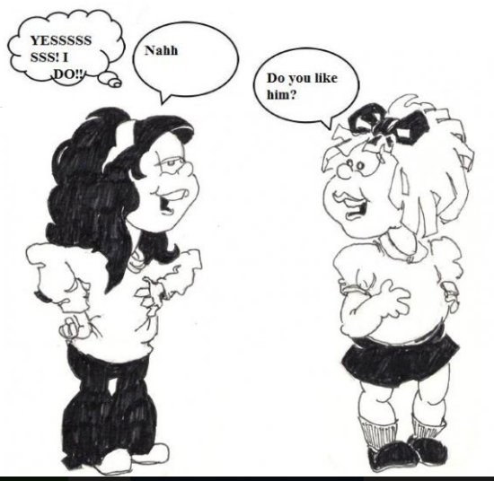

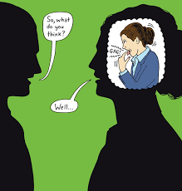
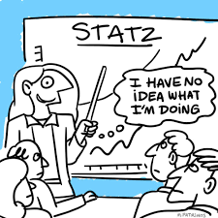
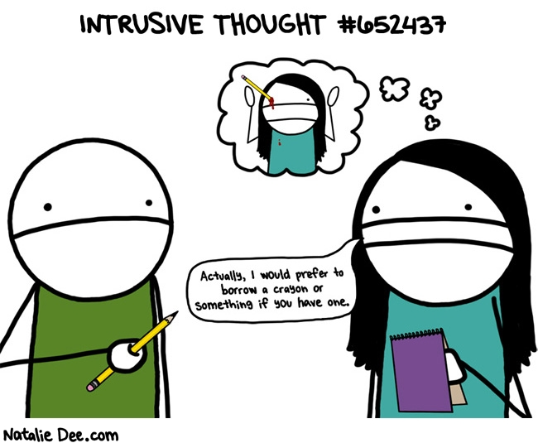

I think that these cartoons all………………………………………………………………………………………….
………………………………………………………………………………………………………………………………………………….

What you see in these cartoons are examples of people saying one thing but thinking something else. We all have an outer voice and an inner voice. Sometimes these voices speak differently and only we can “hear” our inner voice.

Part 2 - Inner Voice in Film

- Watch the following film called The Present. While you are watching, decide what the theme (which we learnt about in the last lesson) is.

The Present

I think this film is about………………………………………………………………………………………..

- Now watch again and stop at these times. Say what the character’s inner voice is saying (what the character is thinking). You will need to infer this information based on what you know, body language and facial expressions. Sometimes the two voices might be the same, in your opinion.

TIME | CHARACTER | OUTER VOICE | INNER VOICE
0:40 | Mom | Why don’t you stop playing and open your present?
1:10 | Son | She’s gotta be kidding me.
2:01 | Son | (Looking at the box)
2:42 | Son | Hmm
3:18 | Son | (Throwing the ball)

Part 3 - Inner Voices in The Moustache

We are going to look at the inner voices of Mike, Mother and Grandmother.
Group A - Mother
Group B - Mike
Group C - Grandmother

In your groups do the following:
- Find quotes from the character. Write them down. (Outer Voice). What do you think their inner voice is saying?
- How does the character change throughout the story?
- What if anything does the character learn?
- What is the theme of this story based on your understanding of this character? (Remember that to choose a theme means you have to be able to support your choice with textual evidence. Look at the example below.)

If I want to decide what the theme is of this cartoon, I might say:
Based on the girl’s thoughts, the theme of this cartoon is irrational fears. I decided this because she sees the sharp pencil and thinks about it in her eye.
In your new groups of 3 (A,B,C) do the following:

- Share your theme and explain why you chose it.
- Choose one of the themes that you all agree is the main theme of the story. (Use the vocabulary below to help you speak in English only.)

Useful Vocabulary: How did you arrive at that theme?
Looking at ....leads me to conclude that…
My opinion is that…
My perspective is that...because...

Part 4 - Reflection

Explain how you chose one theme in your final groups. How did you agree with each other?
………………………………………………………………………………………………………………………………………………………………………………………………………………………………………………………………………………………………………………………………………………………………………………………………………………………………………………………………………………………………………………………………………………………………………………………………………...

Why do you think it is important to be aware of people’s inner voices?
………………………………………………………………………………………………………………………………………………………………………………………………………………………………………………………………………………………………………………………………………………………………………………………………………………………………………………………………………………………………………………………………………………………………………………………………………...

